CSC 322: INNOVATION AND NEW TECHNOLOGY
Comprehensive Lecture Note by Dare Olaniyi Timothy, 2025.
MODULE 1: Introduction to Innovation & New Technology
1.1 What is Innovation?
- Innovation is the process of creating value by applying novel ideas to existing or new problems. Innovation refers to the process of creating new ideas, products, services, processes, or methods that result in significant improvements, advancements, or disruptions in various fields. It involves transforming creative concepts or inventions into practical solutions that address unmet needs, solve problems, or capitalize on opportunities. Innovation often begins with creative thinking or the generation of novel ideas. This involves exploring new perspectives, challenging assumptions, and thinking outside the box to generate breakthrough concepts.
- It involves:
  - Creativity
  - Implementation
  - Value creation
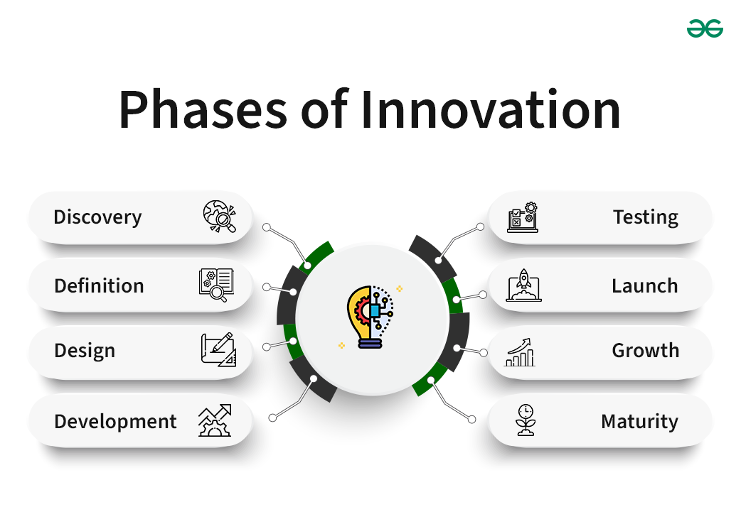

- Types of Innovation
  - Product innovation: New or improved goods/services.
  - Process innovation: New ways of production or delivery.
  - Business model innovation: New value creation models (e.g., Uber, Airbnb).
  - Incremental innovation: Small improvements.
  - Radical/disruptive innovation: Entirely new approaches.
1.2 Concepts of Technology and Technological Change
- Technology: Application of scientific knowledge for practical purposes.
The term “technology” refers to the body of knowledge concerned with the development, improvement, and use of technological means and the connections among human culture, social organization, and the natural world. To put it another way, technology is the application of scientific knowledge to practical ends, such as the development of tools for use in business and daily life. It follows that any application of scientific knowledge to valuable ends is the use of technology.
- Technological Change: It follows the Process of invention, innovation and diffusion. Technological change is the process of creating new technologies and improving existing ones, leading to increased efficiency, new products, and transformed industries. It involves the invention of new technologies, their innovation (initial application), and diffusion (widespread adoption). While it drives progress by creating new products, improving productivity, and lowering costs, it also presents challenges such as workforce disruption and potential environmental impacts.
- Key aspects of technological change: Technological change is an increase in the output possible with a given level of input, often achieved through better and more technology.
Stages: The process unfolds in three main stages.
Invention: The creation of a new technology or process.
Innovation: The first application of the invention.
Diffusion: The spread of the innovation throughout society.
Drivers: Key drivers include research and development (R&D), learning-by-doing (gaining efficiency through practice), and spillovers (knowledge transfer between entities).
Impact:
Positive: It can lead to new products and services, improved operational efficiency, lower costs, and new opportunities for wealth creation.
Negative: It can cause job displacement, introduce pollution, and create a disconnect from the natural environment.
Examples
    - Communication: The evolution of the telephone from a simple voice-calling device to a multi-functional smartphone that can send texts, emails, and connect to the internet.
    - Automation: A vacuum cleaning robot that efficiently cleans floors with reduced human effort.
    - The Industrial Revolutions:
- First: Mechanization using steam and water power.
- Second: Mass production powered by electricity.
- Third: Automation through electronics and computers.
- Fourth: Driven by AI, big data, and high-speed mobile internet, which is rapidly changing many aspects of life.

    - What is Technology Innovation?
Technology innovation is defined as the creation and application of new or improved technologies, tools, systems, and processes that bring about significant advancements or breakthroughs in various fields. It involves harnessing knowledge, expertise, and resources to develop innovative solutions that solve problems, improve efficiency, drive progress, and deliver value.

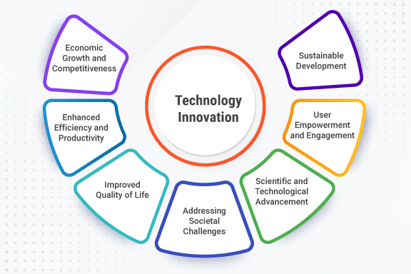
- Drivers of technological change include:
  - Research & development (R&D)
  - Market demand
  - Competition
  - Emerging scientific breakthroughs
1.3 Innovation vs Invention
Invention | Innovation
New idea, product or process | Applying invention to create value
Focus on discovery | Focus on commercialization
Not always useful | Must be useful or market-ready

MODULE 2: THE INNOVATION PROCESS
2.1 Stages of Innovation
- Idea Generation
- Idea Screening
- Concept Development
- Prototype Development
- Testing and Validation
- Commercialization
- Diffusion and Adoption

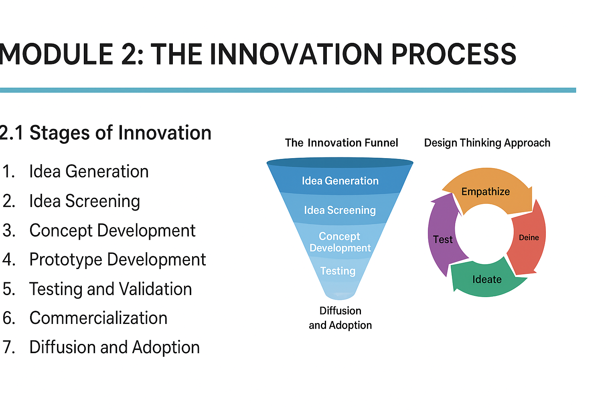
2.2 The Innovation Funnel
A model showing how many ideas enter the top and only few survive to implementation.

2.3 Design Thinking Approach
The Design Thinking approach is a human-centered, iterative problem-solving methodology that uses a five-stage process: Empathize, Define, Ideate, Prototype, and Test. It focuses on understanding user needs to develop innovative and practical solutions, and is a non-linear process that allows for revisiting earlier stages based on new insights.
The five stages of the Design Thinking approach
Stages: Empathize, Define, Ideate, Prototype, Test
- Empathize: Research users to deeply understand their needs, behaviors, and motivations.
- Define: Synthesize your findings from the empathy stage to clearly define the core problem you are trying to solve from the user's perspective.
- Ideate: Brainstorm a wide range of creative solutions to the defined problem, challenging assumptions and generating as many ideas as possible.
- Prototype: Build low-fidelity versions of your potential solutions to make them tangible and testable. This can be anything from a sketch to a simple model.
- Test: Put your prototypes in front of users to gather feedback. Use this feedback to refine the solution or even to go back to earlier stages if needed.
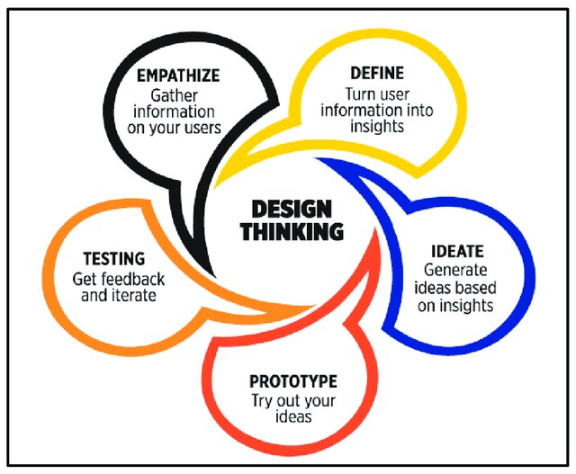
MODULE 3: TYPES OF EMERGING TECHNOLOGIES
3.1 Artificial Intelligence & Machine Learning
- AI systems emulate human intelligence.
- Applications:
  - Healthcare (diagnosis, predictive systems)
  - Natural Language Processing
  - Robotics
  - Automation
3.2 Cloud Computing
- Delivery of computing services over internet.
- Service models: IaaS, PaaS, SaaS.
- Benefits: scalability, cost-efficiency.
3.3 Internet of Things (IoT)
- Network of interconnected devices.
- Applications: smart homes, smart agriculture, wearables.
3.4 Blockchain & Cryptocurrency
- Decentralized ledger technology.
- Use cases: finance, supply chain, identity management.
3.5 Quantum Computing
- Uses quantum bits for extreme computation power.
- Potential for cryptography, optimization, drug discovery.
3.6 Biotechnology & Bioinformatics
- Genetic engineering, DNA sequencing, medical research.
- Personalized medicine and bio-based innovations.
3.7 3D Printing & Additive Manufacturing
- Layer-by-layer creation of objects.
- Used in engineering, medicine, fashion, aerospace.
3.8 Robotics & Automation
- Industrial robots, drones, autonomous vehicles.

MODULE 4: DISRUPTIVE INNOVATION & TECHNOLOGIES
4.1 What is Disruptive Innovation?
Disruptive innovation is a process where a smaller company with fewer resources successfully challenges established businesses. Initially, disruptive products or services may appear inferior to established solutions, but they often appeal to underserved or unserved markets. Over time, as they improve, they can displace industry leaders.
While sustaining innovations improve existing products for existing customers, disruptive innovations target new customer bases or lower-end market segments, gradually moving upmarket as they gain popularity and acceptance.
- Coined by Clayton Christensen.
- New technology that displaces existing markets.
- Examples:
  - Smartphones, feature phones
  - Netflix, Blockbuster
  - Digital photography, film
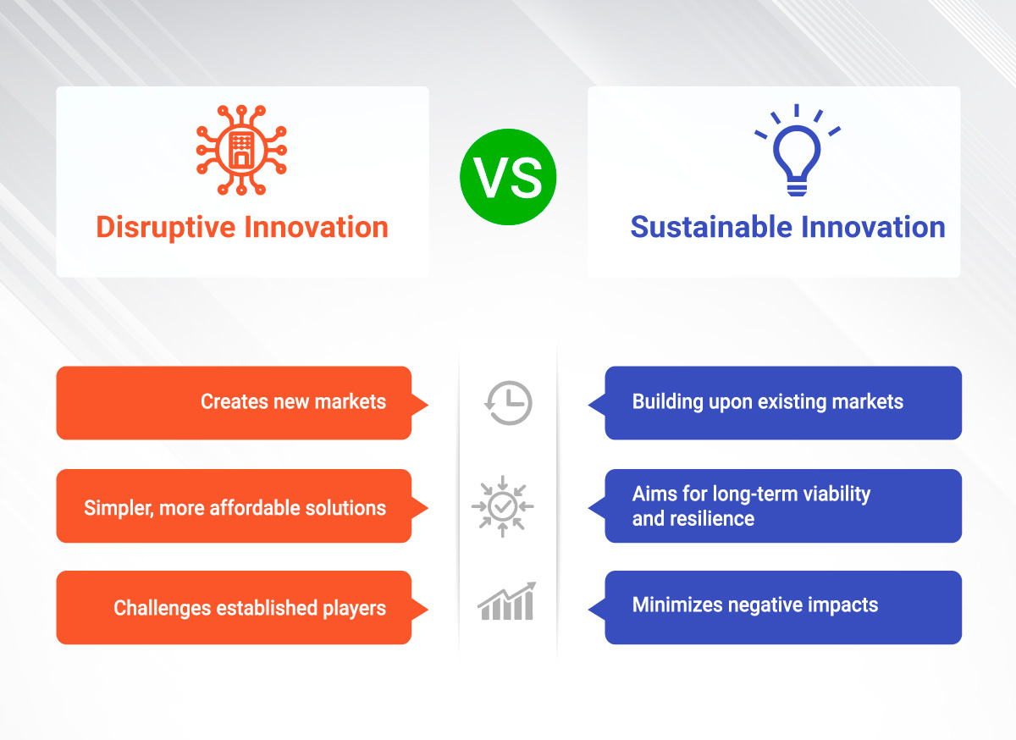
4.2 Characteristics of Disruptive Technologies
- Simpler, cheaper, more convenient at early stages.
- Rapid improvement over time.
- Eventually outperform incumbents.

MODULE 5: THEORIES OF INNOVATION
Theories of innovation explain how new ideas and technologies emerge and spread, with prominent examples including the Diffusion of Innovations Theory, which describes how and why innovations are adopted over time by different groups, and Joseph Schumpeter's economic theories, which focus on the role of entrepreneurs in driving innovation. Other theories, such as those from institutional theory and systems thinking, examine how social, economic, and institutional factors influence innovation processes, while models like the DOI theory identify specific attributes of an innovation that affect its adoption.
Key theories of innovation
Diffusion of Innovations Theory: Developed by Everett Rogers, this theory explains how, why, and at what rate new ideas and technology spread through a culture or social system.
It identifies different groups of adopters, such as innovators, early adopters, the early majority, the late majority, and laggards.
Communication channels (e.g., mass media, interpersonal) are crucial for the spread of information.
Economic Theories: Often attributed to Joseph Schumpeter, these theories highlight the role of entrepreneurs as the driving force behind innovation, disrupting existing markets and creating new ones.
Innovation Systems and Demand-Side Perspectives: This approach views innovation as an interactive and networked process, rather than a linear one.
It looks at the complex interplay between various actors, institutions, and policies that contribute to innovation.
Institutional Theories: These theories emphasize the role of institutions, including rules, norms, and shared beliefs, in shaping innovation.
They examine how institutional "logics" can both enable or constrain innovation and how firms might combine different logics to innovate.
DOI Theory (Diffusion of Innovations Attributes): This model, which is related to diffusion theory, focuses on the characteristics of an innovation itself that influence its adoption rate.
Relative Advantage: The degree to which an innovation is perceived as better than what it replaces.
Compatibility: How well it fits with existing values and practices.
Complexity: How difficult it is to understand and use.
Observability: The extent to which an innovation is visible to others.
Trialability: The degree to which it can be experimented with on a limited basis.
Ambidextrous Theory: This theory suggests that organizations must be able to manage two different types of innovation simultaneously: exploitation of their existing business and exploration of new opportunities
5.1 Schumpeter’s Theory of Innovation
- Innovation as a driver of economic growth.
- The “creative destruction” process.
5.2 Rogers’ Diffusion of Innovation Theory
Adopter categories:
- Innovators
- Early adopters
- Early majority
- Late majority
- Laggards
Factors influencing adoption:
- Relative advantage
- Compatibility
- Complexity
- Trialability
- Observability
5.3 Technology Acceptance Model (TAM)
- Perceived usefulness
- Perceived ease of use

MODULE 6: MANAGEMENT OF INNOVATION
Innovation management is the systematic process of managing and implementing new ideas, from their generation to their successful application, to drive business value and gain a competitive advantage. It involves using a combination of tools, processes, and strategic planning to foster innovation in a company, which can include new products, services, business models, or processes. The key objective is to create a repeatable and measurable approach to innovation that supports sustained growth.
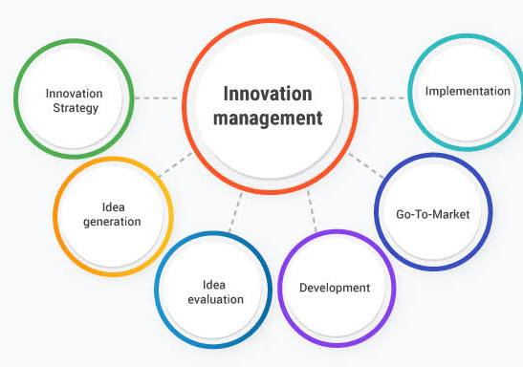
6.1 Organizational Strategies for Innovation
Organizational strategies for innovation include developing a clear innovation strategy aligned with business goals, fostering a supportive culture that encourages risk-taking and collaboration, and establishing a structured process for idea generation, evaluation, and implementation. Measuring innovation through KPIs and allocating adequate resources are also crucial components for success.
1. Develop a clear innovation strategy
- Align with business goals: Define innovation objectives that support the company's overall mission and strategy.
- Create strategic arenas: Pinpoint specific areas for innovation efforts to focus energy and resources.
- Build an attack plan: Outline the vision, roadmap, and potential business outcomes for each innovation initiative.
2. Foster an innovative culture
- Encourage employee voice: Give employees at all levels a role in the creative process and reduce norms that require consensus.
- Promote risk-taking: Lower the perceived cost of failure to encourage experimentation and new ideas.
- Support independent work: Allocate time for employees to work on projects independently.
- Create ambition: Cultivate a grand, motivating goal to rally employees and keep them engaged.
3. Establish a structured innovation process
- Generate ideas: Create a system for employees to submit ideas relevant to the innovation strategy.
- Evaluate and select ideas: Implement processes to assess the feasibility and potential impact of new ideas.
- Implement and monitor: Develop workflows for launching ideas and establishing feedback loops to track progress and gather input.
- Use software: Consider investing in innovation management software to centralize and streamline processes, according to InnovationCast.
4. Measure and manage innovation
- Use key performance indicators (KPIs): Develop and track specific metrics to measure the success of innovation, such as the number of ideas, implementation time, and financial impact.
- Incorporate into performance: Tie innovation to job descriptions and performance reviews to reinforce its importance.
- Allocate resources: Ensure that sufficient financial and human resources are available for innovation initiatives.
- Celebrate successes: Acknowledge and celebrate innovation achievements to reinforce positive behavior.
Open innovation
Open Innovation is an innovation management approach where organizations use both internal and external ideas, knowledge, and technologies to accelerate innovation, reduce cost, and improve market success. It contrasts with closed innovation, where companies rely solely on internal R&D.

Key Ideas in Open Innovation
- External knowledge is valuable
Organizations actively seek ideas from universities, startups, customers, suppliers, and research labs.
- Internal ideas can go outside
Not all internal innovations must be developed in-house; they can be licensed, sold, or jointly developed.
- Collaboration drives faster innovation
Partnerships allow organizations to share risks, costs, and expertise.
Forms of Open Innovation
1. Inbound (Outside-In) Innovation
Using external sources to improve internal innovation.
Examples:
- Licensing external patents
- Hackathons
- Crowdsourcing ideas from users
- Academic partnerships
2. Outbound (Inside-Out) Innovation
Allowing internal inventions to be used externally.
Examples:
- Licensing internal technology
- Spin-off companies
- Joint ventures
3. Coupled Innovation
A combination of inbound and outbound, usually through alliances.
Examples:
- Joint development agreements
- Research consortia
Benefits of Open Innovation
- Faster product development
- Access to specialized expertise
- Reduced R&D costs
- Increased creativity
- Better competitive advantage
- New revenue streams through licensing
Challenges of Open Innovation
- Intellectual property risks
- Trust and collaboration issues
- Cultural resistance within organizations
- Knowledge leakage to competitors
Examples of Open Innovation
1. Procter & Gamble — “Connect + Develop”
P&G sources more than half of its innovation from external partners.
2. Tesla
Tesla made several of its patents open to accelerate the electric vehicle industry.
3. Linux/Foundation Open-Source Projects
Thousands of developers contribute code openly.
4. Local/Nigeria & Africa Examples
- Andela’s remote talent ecosystem
- Interswitch collaborations with banks and fintech startups
- MTN innovation challenges for developers
Closed innovation
Closed Innovation is an innovation model in which an organization develops new ideas, products, and technologies internally without significant external collaboration.
All research, development, and commercialization activities are performed inside the company, and knowledge is tightly protected.
This model dominated the 19th and 20th centuries before globalization and digital transformation made collaboration easier.

Key Characteristics of Closed Innovation
- Internal R&D Only
All ideas come from within the company—employees, internal research units, and labs.
- Strict Intellectual Property (IP) Protection
Patents, trade secrets, and copyrights are guarded to prevent competitors from accessing innovations.
- Vertical Integration
The company controls the entire innovation process: research → design → development → production → distribution.
- High Investment in R&D
Because all innovation is internal, companies spend heavily on research facilities, experts, and infrastructure.
- Secrecy and Confidentiality
Projects are kept hidden from competitors until product launch.

The Closed Innovation Process
- Internal research
- Technology development
- Prototype creation
- Internal testing
- Commercialization
- Market protection via IP
This is also known as the “pipeline model”, where ideas move through an internal, linear process.

Advantages of Closed Innovation
- Strong control over the innovation process
- Better IP protection and reduced risk of knowledge leakage
- High-quality, consistent results due to internal expertise
- Competitive advantage derived from exclusive technologies
- Strong brand reputation from proprietary innovations

Limitations of Closed Innovation
- High cost due to large internal R&D teams
- Slower development cycle compared to collaborative models
- Limited creativity (ideas only from employees)
- Risk of technological lock-in—missing external breakthroughs
- Reduced flexibility in fast-changing markets

Examples of Closed Innovation
1. Apple (Historically)
Apple traditionally designs hardware and software internally and maintains strict secrecy.
2. Early IBM
IBM formerly relied on internal R&D labs, rarely engaging external developers.
3. Pharmaceutical giants (legacy model)
Companies like Pfizer used to rely heavily on internal labs before transitioning toward open innovation partnerships.

Closed vs Open Innovation (Quick Comparison)
Feature | Closed Innovation | Open Innovation
Ideas come from | Inside company only | Both inside and outside
Collaboration | Minimal | Strong industry & academic partnerships
Cost | High | Shared
Speed | Slower | Faster
IP | Strict, protected | Shared, licensed, or co-developed
Creativity | Limited | Broader and diverse

- Innovation culture
- Cross-functional teams
- R&D investment
6.2 Innovation in Small vs Large Organizations
- Small firms: more flexible, low bureaucracy.
- Large firms: more resources, structured processes.
6.3 Protecting Innovation
- Patents
- Trademarks
- Copyrights
- Trade secrets

MODULE 7: ENTREPRENEURSHIP & INNOVATION
7.1 Entrepreneurship Defined
- Using innovation to create economic opportunities.
7.2 Startup Innovation Ecosystem
- Incubators
- Accelerators
- Venture capital
- Angel investors
- Government policies
7.3 Business Model Canvas
Components:
- Customer segments
- Value proposition
- Channels
- Customer relationships
- Revenue streams
- Key resources
- Key activities
- Key partners
- Cost structure

MODULE 8: SOCIAL & ETHICAL IMPLICATIONS OF NEW TECHNOLOGIES
8.1 Ethical Issues
- Privacy
- Algorithmic bias
- AI ethics
- Surveillance concerns
8.2 Environmental Impact
- E-waste
- Energy consumption
- Sustainable technology
8.3 ICT and National Development
- Digital transformation
- E-government
- Education and health (e-learning, e-health)

MODULE 9: CASE STUDIES OF TECHNOLOGY INNOVATION
Examples
- Tesla (electric vehicles & batteries)
- SpaceX (reusable rockets)
- Apple (consumer electronics)
- Amazon (digital retail & cloud)
- African innovations:
  - M-Pesa mobile money
  - Andela remote tech training
  - Flutterwave fintech innovation

MODULE 10: FUTURE TRENDS IN INNOVATION & TECHNOLOGY
- Metaverse & Extended Reality (XR)
- Brain-Machine Interfaces (BMI)
- Smart cities
- Autonomous systems
- Synthetic biology
- Edge Computing
- Renewable energy innovations

Recommended Readings
- Clayton Christensen – The Innovator’s Dilemma
- Everett Rogers – Diffusion of Innovations
- Peter Drucker – Innovation and Entrepreneurship
- Harvard Business Review Articles on Innovation
- https://www.researchgate.net/publication/359783710_Highlighting_a_Digital_Platform_to_Assess_Young_People_Needs_Reaching_and_Engaging_Adolescents_and_Young_Adults_for_Care_Continuum_in_Health_Project_REACH/figures?lo=1

